WHF Summer Holiday Club 2026


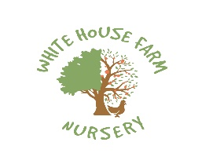



Come and join us at Whitehouse Farm for our exciting Summer Club with lots of activities and fun filled days!

Starting 27th July- last session Friday 28th August
Forest School 9-3: Every Tuesday and Thursday at our woodland site or at our Outdoor School.
Lots of outdoor adventures and fun including:
Outings to local parks and areas Arts and Crafts
Sports and games Baking
Science Experiments Water fun

To book your place please contact us on 01949 845451 or email on Office@whfnursery.co.uk
9am-3pm- £36.00
9am-5pm- £46.00
All sessions include homemade meals with Pudding and snacks
*Please note the planned days are subject to change, we will inform you of any changes ASAP.

